**Assignment 2: Monitors and Semaphores**

Atuhaire Ambala and Ricardo Escarcega

Prof. Artzi

CST 315

May 26th 2024

**Assignment 2: Monitors and Semaphores**

In the Producer-Consumer problem, we manage a bounded buffer, which is a fixed-size data structure shared between multiple producer and consumer threads. Producers generate data items and place them into the buffer, while consumers remove and process these items. To ensure smooth and safe operation, synchronization mechanisms are employed to prevent race conditions and deadlocks. Using semaphores, we can implement this by defining three key semaphores: a mutex for mutual exclusion, an 'empty' semaphore to count the number of available slots in the buffer, and a 'full' semaphore to count the number of filled slots.

Producers wait if the buffer is full and proceed to add items to the buffer when space is available, incrementing the 'full' semaphore and releasing the mutex. Similarly, consumers wait if the buffer is empty, remove items when available, decrement the 'full' semaphore, and release the mutex. This coordination ensures that producers and consumers operate independently and efficiently, maintaining the integrity of the shared buffer. Monitors can also be used, providing mutual exclusion and condition variables to manage the producer and consumer interactions in a higher-level abstraction, ensuring that the buffer is accessed safely and without conflicts.

**Responsibilities**

1. Ricardo
   * Designing Code algorithm
   * Creating Code algorithm
   * Testing and validation Algorithm
2. Atu

* Designing Code Algorithm
* Creating Documentation
* Testing and Validating Algorithm

**Monitor Pros**

1. Thread Safety:
   * The use of a mutex ensures that only one thread can access the critical section of the code at a time, preventing race conditions and ensuring data integrity.
2. Coordination Between Threads:
   * Condition variables (pthread_cond_t) provide a mechanism for threads to wait for certain conditions to be met. This allows efficient coordination between producer and consumer threads, ensuring that producers wait when the buffer is full and consumers wait when the buffer is empty.
3. Modularity and Readability:
   * The use of monitors (mutexes and condition variables) encapsulates the synchronization logic within well-defined constructs, making the code more modular and easier to understand.
4. Resource Management:
   * Condition variables allow threads to sleep efficiently while waiting for a condition, rather than continuously polling, which would waste CPU resources.
5. Flexibility:
   * Monitors provide flexibility in synchronizing access to shared resources, allowing complex synchronization scenarios to be handled efficiently.

**Monitor Cons**

1. Complexity:
   * The use of mutexes and condition variables adds complexity to the code. Proper handling of locks and conditions requires careful design to avoid deadlocks and other synchronization issues.
2. Potential for Deadlocks:
   * Incorrect usage of mutexes and condition variables can lead to deadlocks, where two or more threads wait indefinitely for each other to release resources.
3. Performance Overhead:
   * Acquiring and releasing locks introduces performance overhead. In high-performance applications, this overhead can become significant, especially if contention for locks is high.
4. Scalability Issues:
   * As the number of threads increases, contention for the mutex can become a bottleneck, limiting scalability. This can be mitigated with more sophisticated synchronization techniques, but at the cost of additional complexity.
5. Difficulty in Debugging:
   * Synchronization issues such as race conditions and deadlocks can be difficult to reproduce and debug, requiring advanced tools and techniques to diagnose and resolve.

**Monitor Code**

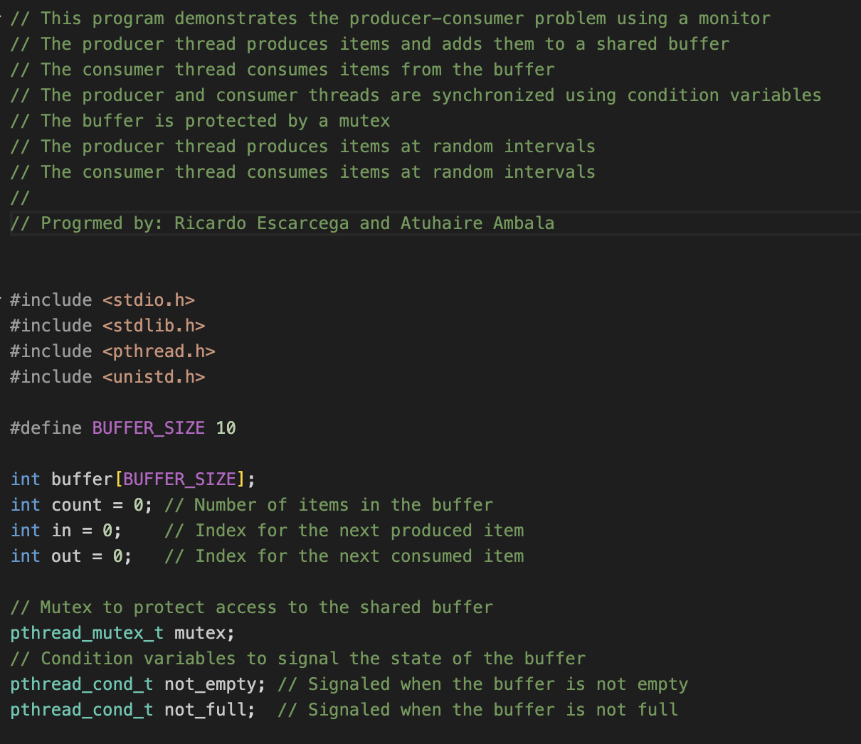

**Monitor Execution Results**

**Semaphores Pros**

1. Simple Implementation:
   * Semaphores provide a straightforward way to synchronize access to shared resources. The provided code demonstrates how semaphores can manage access to a bounded buffer by signaling the availability of empty and full slots.
2. Efficiency:
   * Semaphores are low-level synchronization primitives that can be very efficient. They avoid busy-waiting by allowing threads to block and be woken up when the resource becomes available.
3. Flexibility:
   * Semaphores can be used to solve various synchronization problems, not just the producer-consumer problem. They are versatile and can handle different synchronization scenarios.
4. Availability in Standard Libraries:
   * Semaphores are widely available in many programming languages and environments, including C with POSIX threads (pthreads). This makes them accessible and easy to use in different systems.

**Semaphores Cons**

1. Potential for Errors:
   * Semaphores can lead to complex and error-prone code. Incorrect use of semaphore operations (such as sem_wait and sem_post) can result in deadlocks, race conditions, or resource starvation.
2. Difficulty in Understanding:
   * Understanding and debugging semaphore-based code can be challenging, especially for those not familiar with concurrent programming concepts. The non-intuitive nature of semaphores can make maintenance harder.
3. Lack of Abstraction:
   * Semaphores operate at a low level, requiring explicit management of synchronization logic. Higher-level abstractions (like monitors or condition variables) can provide more readable and maintainable code.
4. Scalability Issues:
   * In more complex systems with many producers and consumers, semaphore-based solutions might not scale well. Managing a large number of semaphores and ensuring proper synchronization can become cumbersome.

**Semaphores Code**

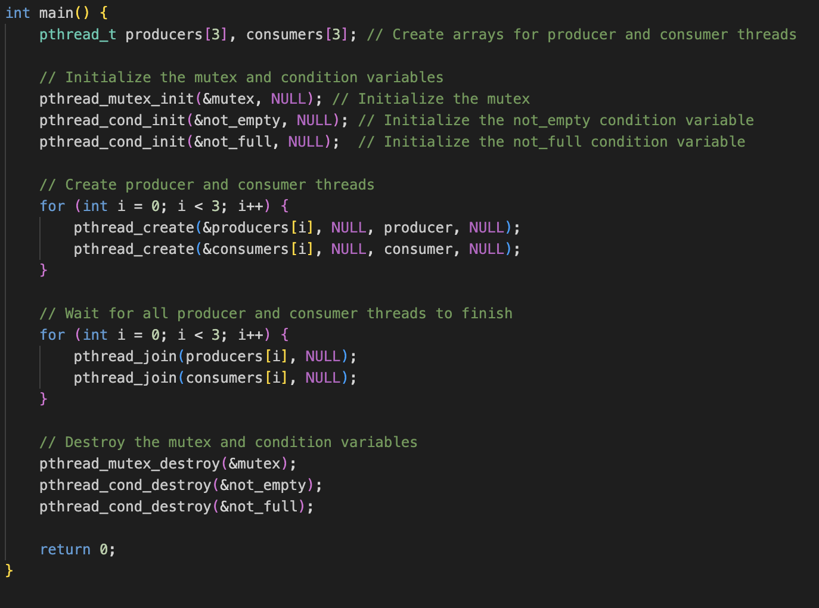

**Semaphores Execution Results**

**Recommendation**

Monitors, with their high-level abstraction and built-in mutual exclusion, provide a cleaner and more understandable approach to solving the producer-consumer problem. For a simple synchronization scenario like this, the use of monitors can lead to code that is easier to write, understand, and maintain, making it a strong choice despite the problem's simplicity.

1. Ease of Understanding and Maintenance:
   * Monitors provide a higher-level abstraction that simplifies the synchronization logic. The encapsulation of mutual exclusion and condition variables within the monitor makes the code easier to understand and maintain, reducing the likelihood of errors.
2. Built-in Mutual Exclusion:
   * Monitors inherently manage mutual exclusion, eliminating the need for explicit lock and unlock operations. This built-in feature reduces the risk of forgetting to release a mutex, which can lead to deadlocks.
3. Cleaner Synchronization Logic:
   * Using monitors allows for cleaner and more readable code. The synchronization logic is more intuitive because condition variables and wait/signal mechanisms are integrated into the monitor construct, making the code more concise and less error-prone.
4. Simplified Condition Management:
   * Monitors handle condition variables in a straightforward manner, allowing threads to wait and be notified when certain conditions are met. This simplifies the management of empty and full slots in the buffer, making the producer-consumer interactions clearer.

**Testing and Validation**

To ensure the correctness and robustness of our producer-consumer implementation, we conducted extensive testing and validation. We ran the code with three producer and three consumer threads to verify basic functionality. We observed that producers correctly generated items and placed them into the buffer, while consumers successfully removed and processed these items.

To further validate our implementation, we introduced modifications such as varying the number of producer and consumer threads, adjusting the buffer size, and altering the sleep intervals to simulate different production and consumption rates. For instance, we tested scenarios with more consumers than producers to check if consumers handled empty buffer conditions correctly, and vice versa. Additionally, we deliberately introduced delays in mutex locks and condition variable signals to simulate race conditions and ensured our synchronization mechanisms handled these gracefully without deadlocks or data corruption.

Throughout these tests, our code consistently executed as intended, maintaining the integrity of the shared buffer and demonstrating proper synchronization between producers and consumers. This thorough testing confirmed the reliability and efficiency of our solution in managing concurrent access to the bounded buffer.